Muhammad UMAR

F2021266022

Web Technologies V2

**Assignment Statement:**

**Question # 1: (CLO 4)**

**Design** a calculator using HTML and CSS. Also implement the JavaScript function to perform the arithmetic operations. Arithmetic operations should include the following operations:

* **Addition**
* **Subtraction**
* **Multiplication**
* **Division**

**Submission:**

* You will upload the finalized code on the GitHub public repository and submit the link of that repository.
* Further, you will live your portfolio site on the free server and submit the link of your live portfolio.

**Sample Submission:**

GitHub Link (Code): <https://github.com/abdul194/portfolio>

Live Calculator Link: <https://Abdul-xyz.com/Home>

**Instructions:**

* The GitHub repository should be listed on your own GitHub account.
* GitHub account with university ID is recommended,
* However, you can use the GitHub account with your personal ID but make sure GitHub username should be align your name.
* Any GitHub account with fancy, formal or brand type name like DON123, “Tiny Bite”, Coding Hub will not be acceptable.
* For instance, if your name is “Ahmad” then GitHub account must use this name.
* Lastly, some free servers are listed below. However, you can search more free server for website deployment and chose the best server according to your need.

**HTML:**

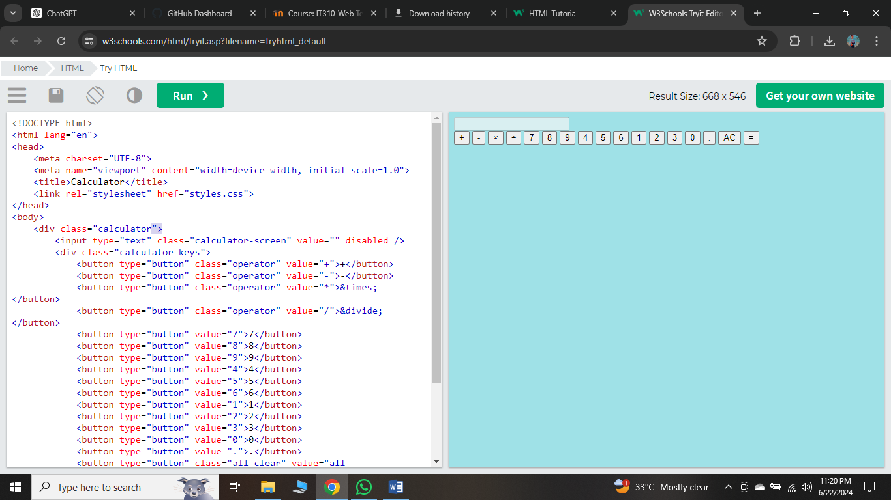

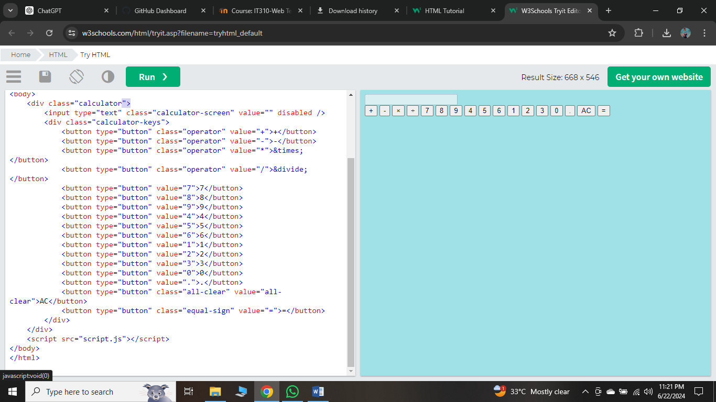

**CSS:**

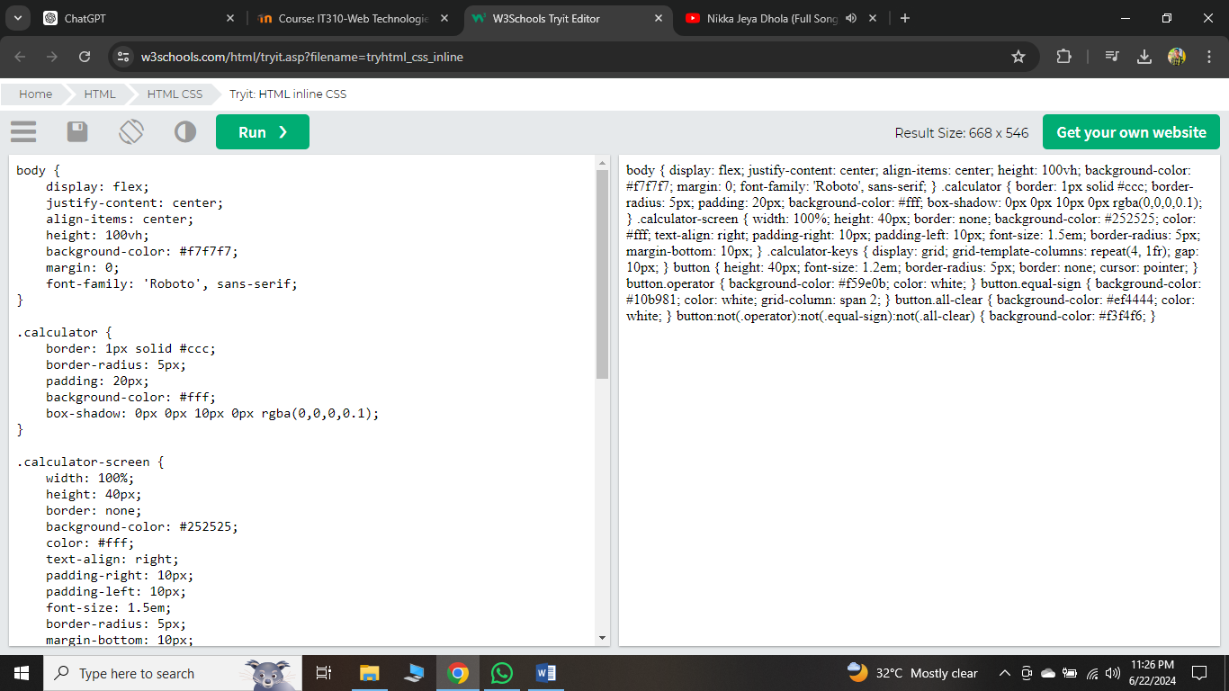

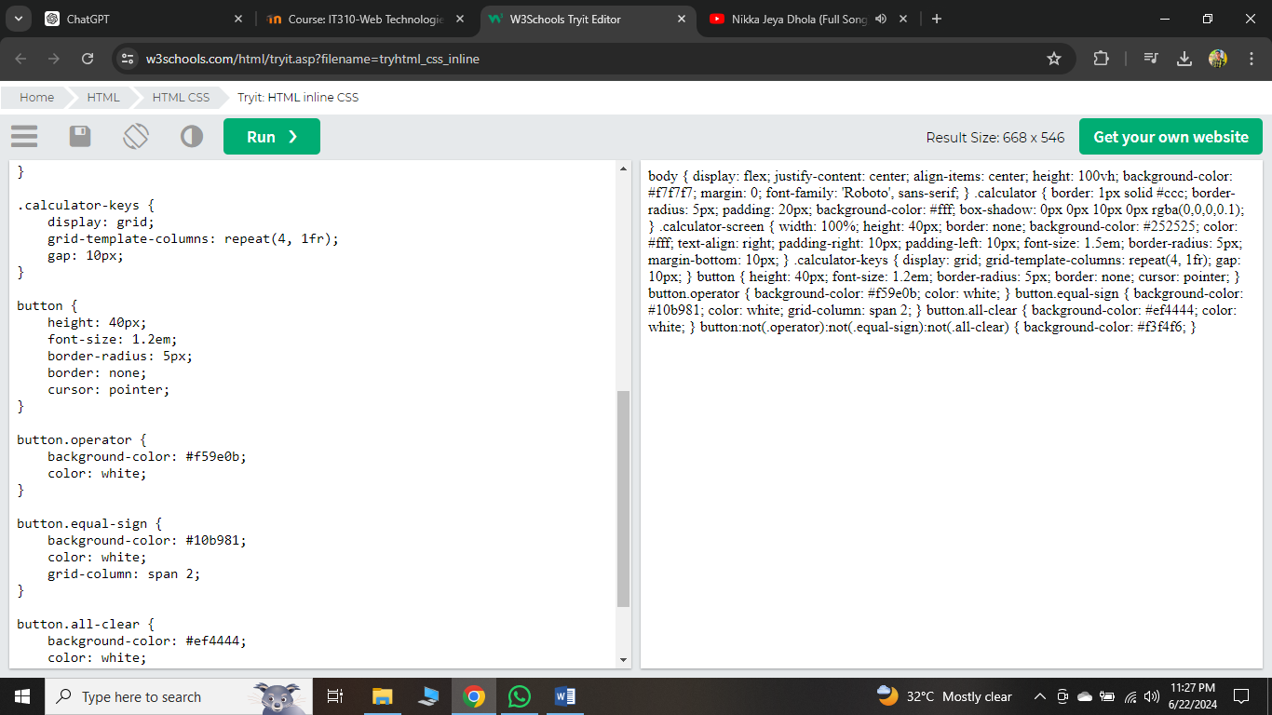

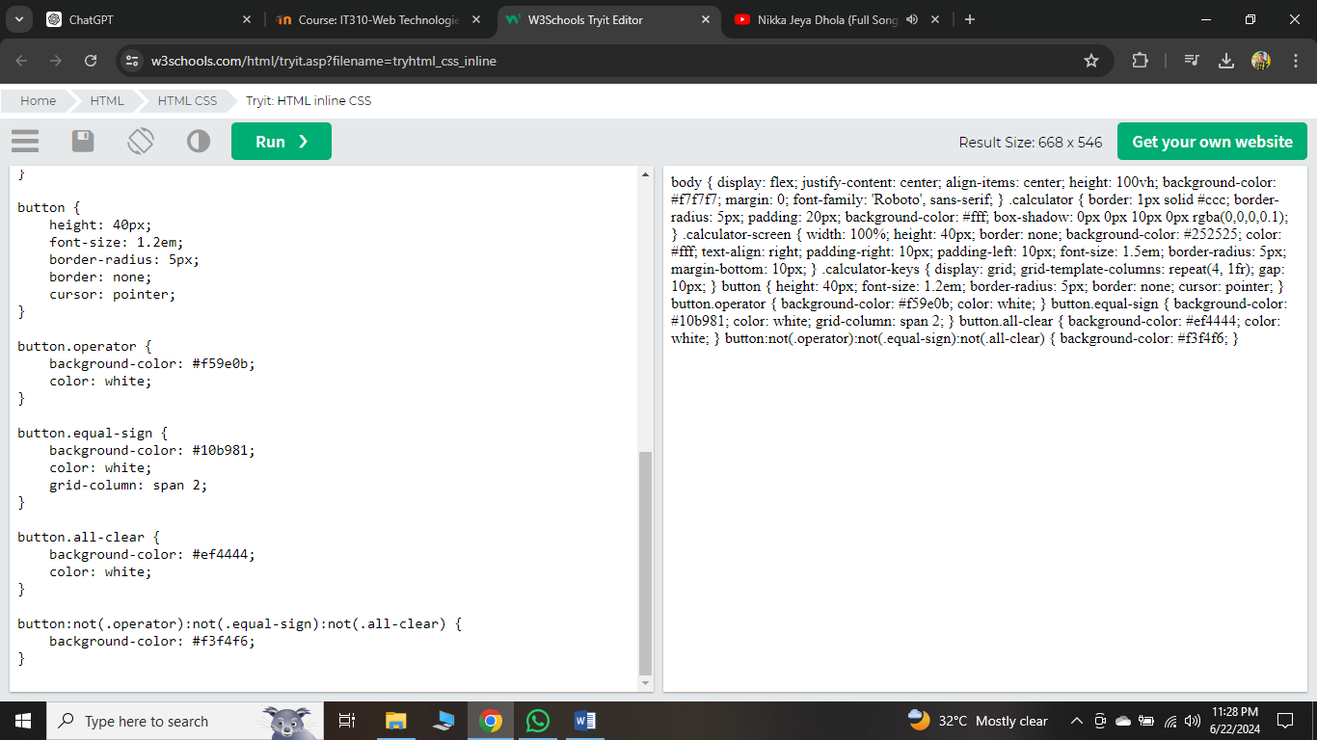

**JavaScript:**

